MAT-DOC
Mounting Assistive Technology Documentation

Version 0.2

[Enter Name in Properties]

Section 1 – Pre Assessment Information
SUMMARY INFORMATION
Client Name | Form Start Date |  | Form Completion Date |  | Form Completed By |  | Equipment Issue Date
[Enter Name in Properties] | 30/05/2016
Lead Clinician |  | Organisation |  | Email Address |  | Phone Number
 |  | [Enter service name in properties]

CLIENT INFORMATION
Client’s weight | kg | Estimated/Measured
Weight change expected? | Decrease / No expected change / Increase
Transfer method | Hoist / Standing / Side (specify which) / Other (specify)
Access to client required? | Front / Rear / Left / Right / No
Transport method | None / Taxi / Adapted vehicle / School bus or public transport
Has unintentional movement? | Yes / No
Has intentional movement? | Yes / No
Additional comments

EXISTING EQUIPMENT

EQUIPMENT TO BE MOUNTED
Devices | Access Method | Mounting Plate | Total Weight
 |  | Daessy/Rehadapt | kg

ENVIRONMENTAL CONSIDERATIONS
Home | Where is time spent and use of the device required?
Home | What wheelchairs/seating systems are used?
Home | Will the device need to be accessed from bed?
School/ Work | Where is time spent and use of the device required?
School/ Work | What wheelchairs/seating systems are used?
School/ Work | Will the device be accessed at any desks?
Outside/  Leisure | Where is time spent and use of the device required?
Outside/  Leisure | What is the terrain like? e.g. slopes/uneven
Outside/  Leisure | What wheelchairs/seating systems are used?
Other | Describe any other locations where the technology may be required?
Other | Is there any other equipment that should be considered (lying support, standing support, or walker for example)

PHOTOS
Overall View | Device Held in Place
[Insert photo of overall view here] | [Show the device and access devices held in place]
[Insert additional photo here] | [Insert additional photo here]
[Insert additional photo here] | [Insert additional photo here]
[Insert additional photo here, add more rows if needed] | [Insert additional photo here, add more rows if needed]

DECISION TABLE
Ref | Mounting Type (delete as appropriate) | Mounting Equipment Provided
1 | Wheelchair/floor/desk/other (specify)
2 | Wheelchair/floor/desk/other (specify)
3 | Wheelchair/floor/desk/other (specify)
4 | Wheelchair/floor/desk/other (specify)
5 | Wheelchair/floor/desk/other (specify)

Section 2 – Wheelbase Information
 | WHEELBASE 1 | WHEELBASE 2 | WHEELBASE 3
If manual, how is the chair propelled? (e.g. self or attendant)
If power, how is the chair controlled? (e.g. joystick)
Joystick/switch site
Wheelbase Owner
Owner Contact Phone
Owner Asset ID
Manufacturer
Model
Serial number
Tube size and type
Base weight (kg)
Max user weight (kg)
Any obstacles to mounting? (e.g. joystick or tray)
Expected base review date
Expected seat review date

Section 3.1 – Feasibility of Wheelchair Mounting
WHEELBASE MOUNTING DECISION TREE OUTCOME
Decision Tree | 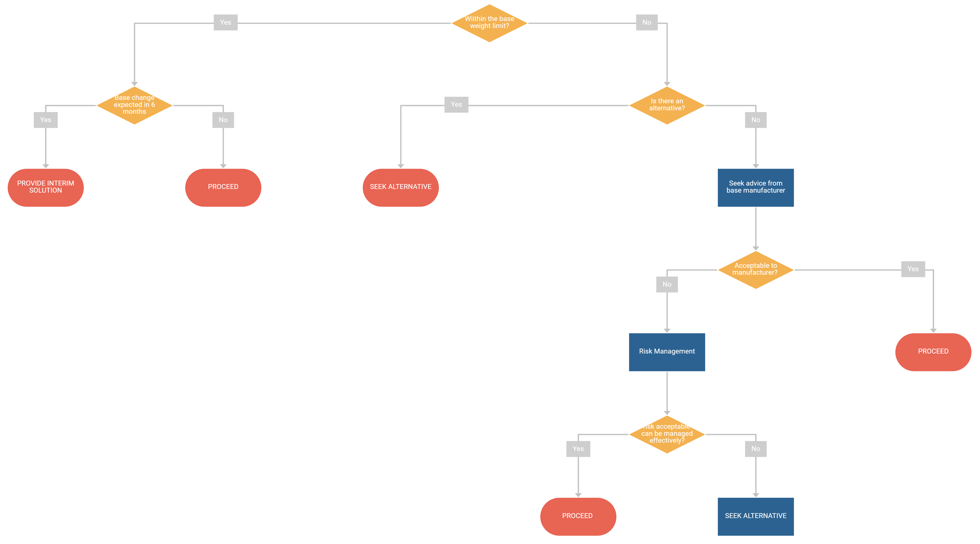
Outcome | Seek alternative / Provide interim solution / Proceed
Notes

WHEELBASE WEIGHTS
Wheelchair Ref (from Section 1) | Asset ID | Weight Limit  A | Weight of Devices  B | Weight of Mount  C | Weight of User  D | Available Capacity  = A – B – C – D

SYSTEM DECISION |  | Y/N
Factors considered | Weight of AAC device
Factors considered | Type of terrain chair will be used on (indoors, outdoors, rough, smooth)
Factors considered | Desired position of AAC device
Factors considered | Should device be fixed in place, or does it need to move
Factors considered | Does device need to swing away to side of wheelchair when not in use
Factors considered | Does position of device need to be altered for driving
Factors considered | Quick removal of device from chair
Factors considered | Will device be moved/removed by user or carer
Factors considered | Compatibility with other mounting systems (including other chairs, floor mounts, desk mounts)
Decision | Daessy
Decision | Rehadapt
Decision | Mount n Mover
Decision | Other (specify)
Notes

LOCATION DECISION |  | Y/N
Factors considered | Tray
Factors considered | Wheelchair used at desks and tables
Factors considered | Method of transfer (likely to change in future?)
Factors considered | Carer activities (e.g. feeding) performed from a particular side
Factors considered | Mount must not impede operation of footplates, brakes, tilt mechanism, means of propulsion, tie-down points, folding of wheelchair
Decision | Left
Decision | Right
Decision | Centre
Decision | Other (specify)
Notes

Section 3.2 – Feasibility of Desk/Table Mount
TABLE/DESK MOUNT DECISION TREE OUTCOME
Decision Tree | 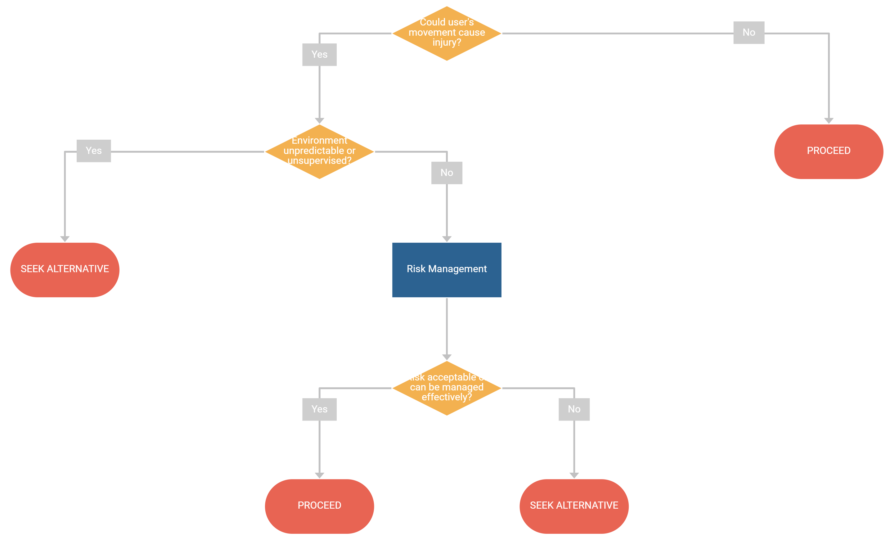
Outcome | Seek alternative / Proceed
Notes

SYSTEM DECISION |  | Y/N
Factors considered | Weight of AAC device
Factors considered | Size and stability of surface where mount is being used
Factors considered | Desired position of AAC device
Factors considered | Stability of desk mount
Factors considered | Compatibility with other mounting systems (including other chairs, floor mounts)
Factors considered | Could it be placed in an unsafe position
Factors considered | Does it get in the way of other activities
Decision | Daessy
Decision | Rehadapt
Decision | Other (specify)
Notes

Section 3.3 – Feasibility of Floor Mount
FLOOR MOUNT DECISION TREE OUTCOME
Decision Tree
Outcome | Seek alternative / Proceed
Notes

SYSTEM DECISION |  | Y/N
Factors considered | Weight of AAC device
Factors considered | Desired position of AAC device
Factors considered | Stability of floor mount
Factors considered | Environment where floor mount being used (space/manoeuvrability)
Factors considered | Compatibility with other mounting systems (including wheelchairs, floor mounts, desk mounts)
Factors considered | Must not impede care activities
Factors considered | Must not impede operation of other equipment (e.g. bed or armchair)
Decision | Daessy
Decision | Rehadapt
Decision | Other (specify)
Notes

Section 3.4 – Feasibility of Bespoke/HYBRID MOUNT
BESPOKE/HYBRID MOUNT DECISION TREE OUTCOME
Decision Tree | 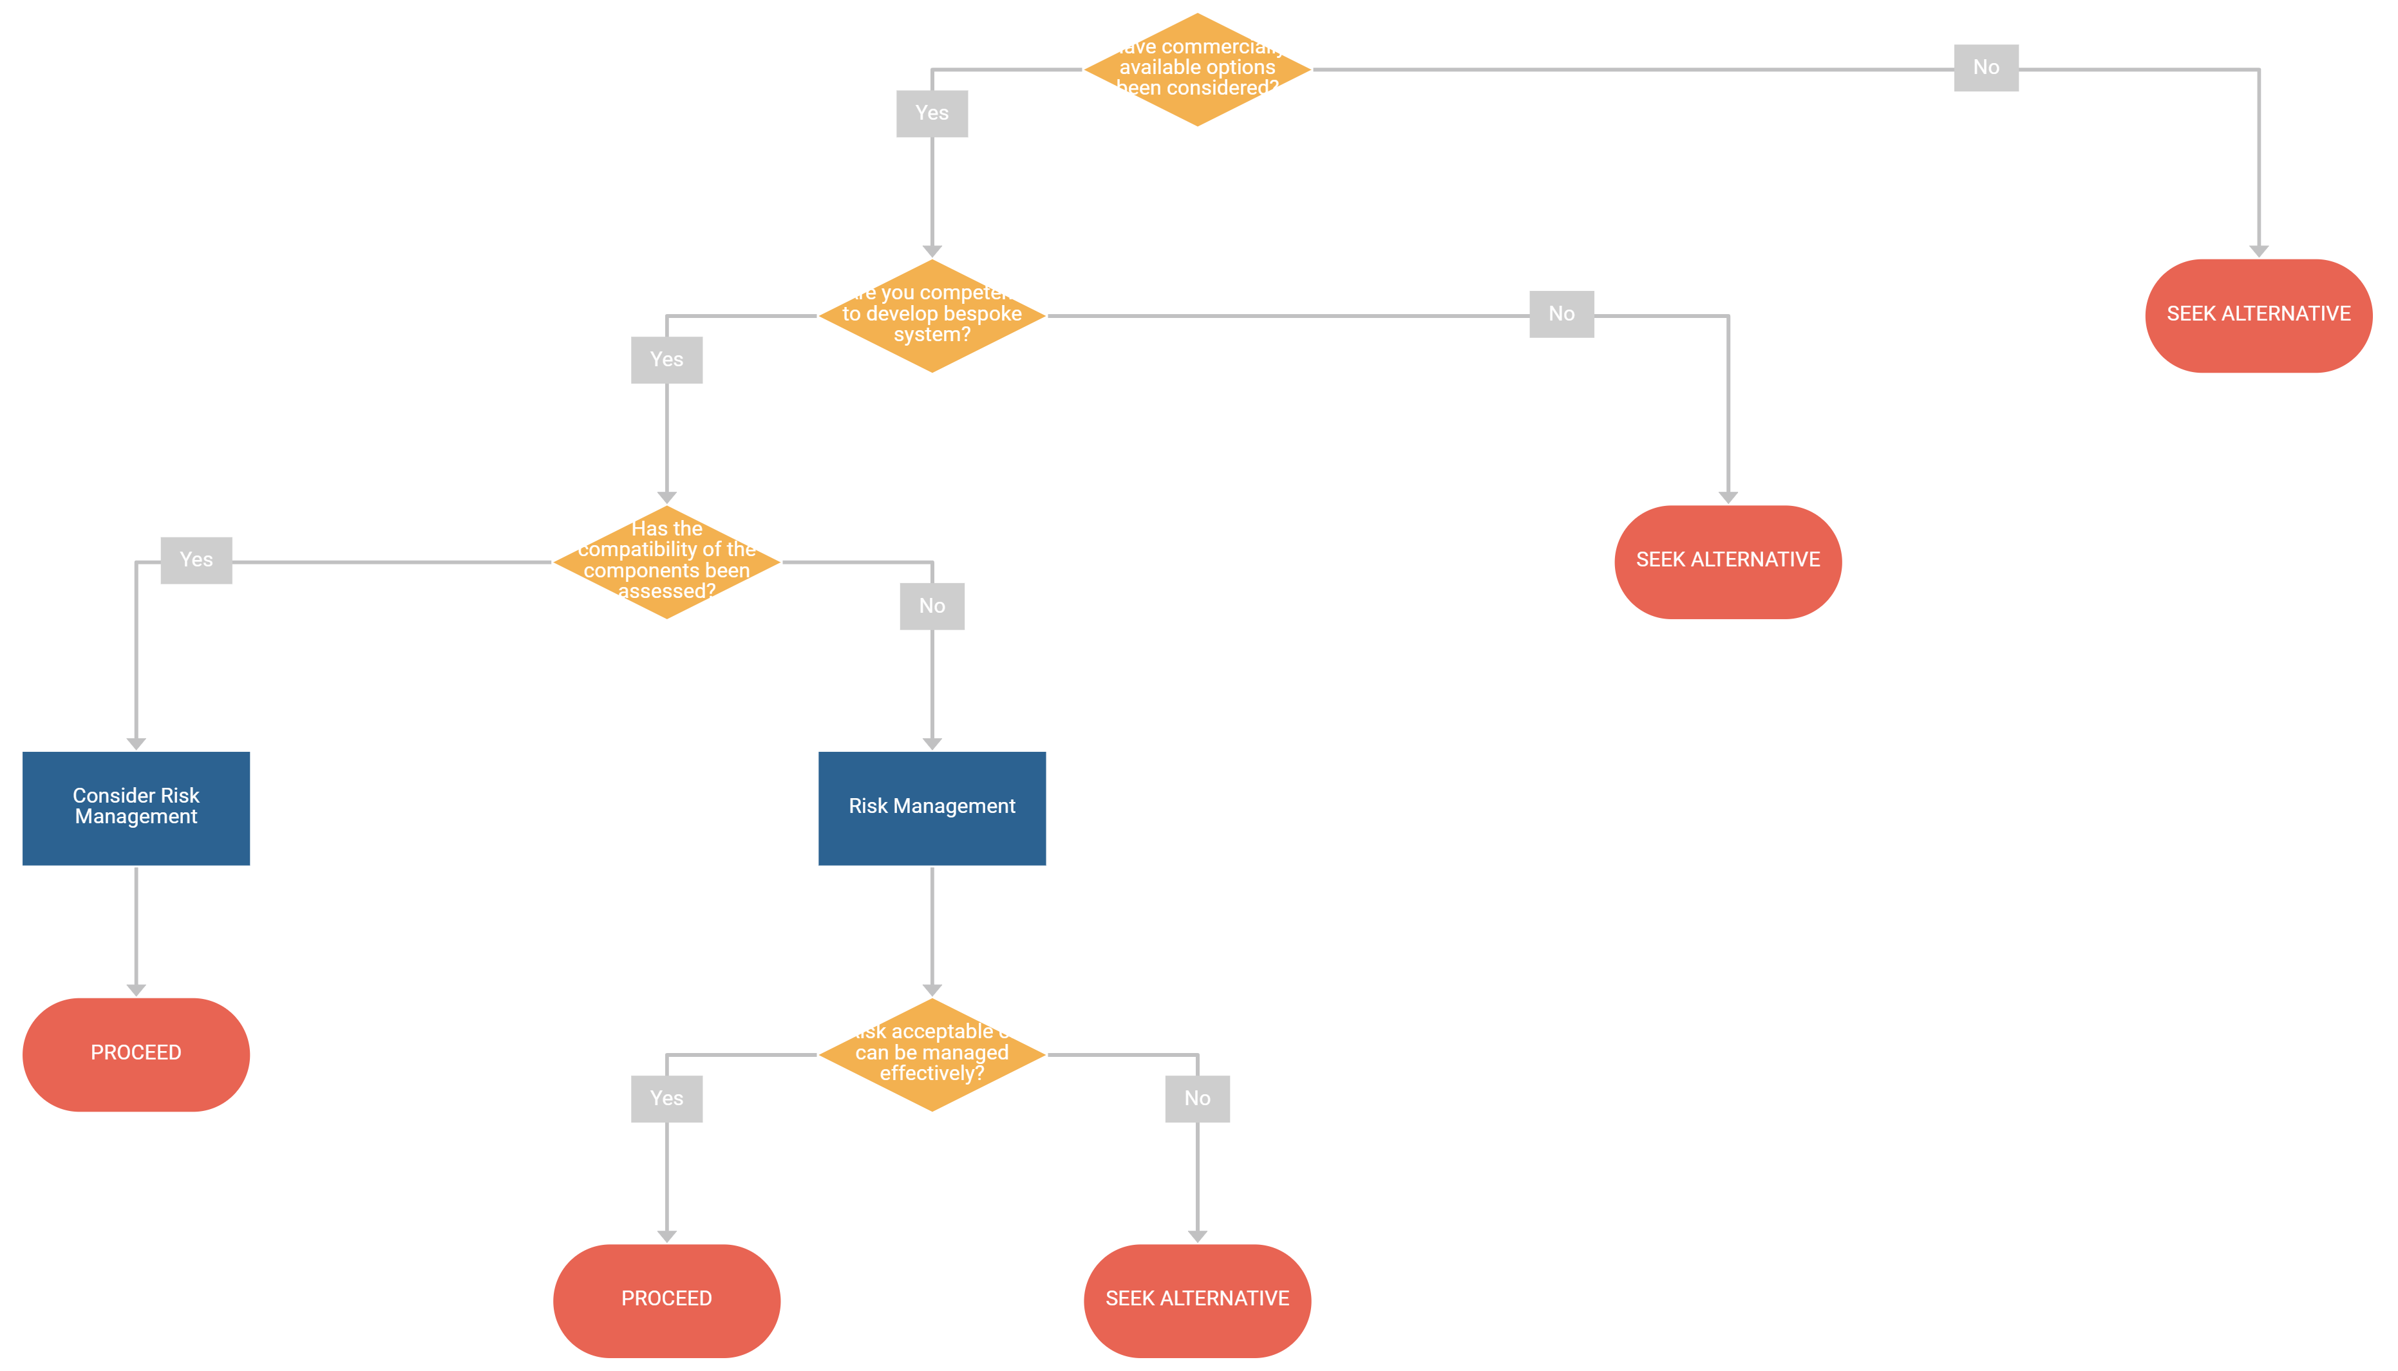
Outcome | Seek alternative / Proceed
Notes

SYSTEM DECISION |  | Y/N
Factors considered | Weight of AAC device
Factors considered | Attachment points
Factors considered | [List other factors considered]
Factors considered | [List other factors considered]
Factors considered | [List other factors considered]
Factors considered | [List other factors considered]
Factors considered | [List other factors considered]
Decision | List components used
Decision | List components used
Decision | List components used
Decision | List components used
Notes

Section 4 – Wheelchair Stability Assessment
 |  |  |  |  |  |  | VALUE
Base Type | Powerchair |  | Manual |  | Hi-Lo chair
Base Type | 1 |  | 3 |  | 5
Location | Inside only |  | Used outside |  | Steep environments
Location | 1 |  | 2 |  | 5
User Movement | Moves within base footprint |  | Moves outside base footprint¹ |  | Moves significantly outside base footprint²
User Movement | 1 |  | 3 |  | 5
Kit Weight³ | < 2kg |  | 2 – 5kg |  | > 5kg
Kit Weight³ | 1 |  | 2 |  | 3
Kit Position | Within footprint |  | < 20cm outside footprint |  | > 20cm outside footprint
Kit Position | 1 |  | 2 |  | 5
Special Seating | Wheelchair seating only | Seat cushion only |  | Special seating |  | Special seating in atypical position⁴
Special Seating | 1 | 2 |  | 3 |  | 5
TOTAL
¹ Centre of gravity remains inside base; ² Centre of gravity of user moving outside of base; ³ Weight of the assistive technology being mounting and the mount itself; ⁴ If the special seat is mounting in a forward position or rearward position.
SCORE | ACTION | DECISION REASONING
<= 9 | Static stability test is unlikely to be required
10 - 18 | Static stability test to be considered by clinician on a case-by-case basis
19 + | Static stability test is recommended

Section 5 – Wheelchair Static Stability Test Results
WHEELBASE DATA
Base Manufacturer | Base Model | Base Serial Number | Wheelbase | Front Track Width | Rear Track Width

SUMMARY |  |  | LOAD CELL DATA (WHERE USED)
Ref | Test 1 |  |  |  | Left (kg) | Right (kg)
Configuration | Before install |  | Front up | Front
Notes |  |  | Level | Front
Notes |  |  | Level | Rear
Notes |  |  | Front down | Rear
RESULTS
Uphill |  | Downhill | Sideways (L down) |  | Sideways (R down)

SUMMARY |  |  | LOAD CELL DATA (WHERE USED)
Ref | Test 2 |  |  |  | Left (kg) | Right (kg)
Configuration | After install |  | Front up | Front
Notes |  |  | Level | Front
Notes |  |  | Level | Rear
Notes |  |  | Front down | Rear
RESULTS
Uphill |  | Downhill | Sideways (L down) |  | Sideways (R down)

Section 6 – Driving Assessment
ASSESSMENT DETAILS
Assessor | Assessor Phone | Assessor Email | Assessment Date | Assessment Location

BACKGROUND INFORMATION
Brief description of environment and conditions in which the assessment took place
Brief description of user’s driving abilities prior to provision of mounting
Any special considerations, relating to driving, identified during pre-provision process? | Yes (detail in notes below) / No
Notes

OBSERVATIONS
User demonstrates ability to | Y/N/- | Comments, inc. how assessed
Negotiate narrow openings
Manoeuvre in areas with limited space
Awareness and avoidance of obstacles
Awareness and avoidance of others
Approach and stop next to desk/table without knocking into it
Follow instructions when driving, e.g. STOP, without being distracted
Other, specify:

Section 7 – Risk Management
RISK IDENTIFICATION CHECKLIST
Is there a risk of any of these hazards occurring?
Ref | Hazard | N | Y/? | Risk
1
2
3
4
5
6
7
8
9
10
11
12
13
14
15

RISK ANALYSIS
If risks have been identified, analyse them further.
Ref | Risk | S | P | T | Notes/management
1
2
3
4
5
6
7
8
9
10
11
12
13
14
15
S – Severity; P – Probability; T – Total (S x P)

SAMPLE 5 x 5 RISK MATRIX
Probability | Severity
Probability | 1 (Negligible) | 2 (Minor) | 3 (Moderate) | 4 (Severe) | 5 (Significant)
1 (Remote) | 1 | 2 | 3 | 4 | 5
2 (Unlikely) | 2 | 4 | 6 | 8 | 10
3 (Possible) | 3 | 6 | 9 | 12 | 15
4 (Likely) | 4 | 8 | 12 | 16 | 20
5 (Certain) | 5 | 10 | 15 | 20 | 25

COLOUR DEFINITIONS
GREEN | Keep risk register to demonstrate awareness of risk
AMBER | Efforts should be made to reduce the risk and risk reduction measures implemented where possible within a defined time period. Further assessment may be necessary to establish more precisely the likelihood of harm as a basis for determining the need for improved control measures.
RED | Very detailed risk assessment needs to be carried out and risks must be reduced.

TERMINOLGY DEFINITIONS
Probability |  | Severity
1 (Remote) | Extremely unlikely to occur in equipment life | 1 (Negligible) | Very unlikely to sustain any injury
2 (Unlikely) | Unlikely to occur in equipment life | 2 (Minor) | Minor injury (first aid not required), repair not required
3 (Possible) | Could occur | 3 (Moderate) | Minor injury first aid required, some damage that will need repair
4 (Likely) | Likely to occur | 4 (Severe) | Significant injury possible that requires hospital treatment
5 (Certain) | Will happen in equipment life | 5 (Significant) | Major injury or death

Section 8 – Safety and Handover Information
HANDOVER DETAILS
Handover Date | Handover Location | Handover By

 | CONTACT INFORMATION
 | Name | Organisation | Phone | Email
Device Provider
Named Receiving Person
First Line Support
Handover Contact

HANDOVER NOTES

